EXP.NO: 3 Write a Servlet program that prints “Hello, World!”
when accessed through a browser.

AIM:
To write a basic Servlet program that demonstrates the use of Java Servlets by printing
“Hello, World!” when accessed through a browser.
ALGORITHM:
1. Input:
• The user makes an HTTP request (usually by entering a URL) through a browser.
2. Servlet Program Flow:
1. Create a Servlet Class:
o Define a Java class that extends the HttpServlet class.
o Override the doGet() method, which handles HTTP GET requests from the
client (browser).
2. Handle HTTP Request:
o In the doGet() method:
▪ Get the PrintWriter object to write the response to the browser.
▪ Set the response content type to text/html.3. Validate E-mail:
o Use a regular expression to check if the email follows the standard pattern:
name@domain.com.
o Ensure that the email contains no invalid characters and matches the required pattern.
o If it doesn&#39;t match, display an error message indicating an invalid email format.
▪ Write the &quot;Hello, World!&quot; message to the response.

3. Compile the Servlet Class:
o Compile the Java Servlet file using the javac command to generate a .class
file.
4. Deploy the Servlet:
o Place the compiled servlet class file in the appropriate directory of the web
application (typically in the /WEB-INF/classes folder).
o Configure the servlet in the web.xml file of the web application or use
annotations.

5. Access the Servlet via Browser:
o Start the Apache Tomcat or another servlet container.
o Access the servlet by entering the appropriate URL (e.g.,
http://localhost:8080/your-webapp/hello).

Code:

HelloServlet.java
import java.io.*;
import javax.servlet.*;
import javax.servlet.http.*;
public class HelloServlet extends HttpServlet {
public void doGet(HttpServletRequest request, HttpServletResponse response)
throws ServletException, IOException {
response.setContentType("text/html");
PrintWriter out = response.getWriter();
out.println("<h1>Hello, World!</h1>");
}
}

Web.xml
<web-app>
<servlet>
<servlet-name>HelloServlet</servlet-name>
<servlet-class>HelloServlet</servlet-class>
</servlet>
<servlet-mapping>
<servlet-name>HelloServlet</servlet-name>
<url-pattern>/hello</url-pattern>
</servlet-mapping>
</web-app>

OUTPUT:

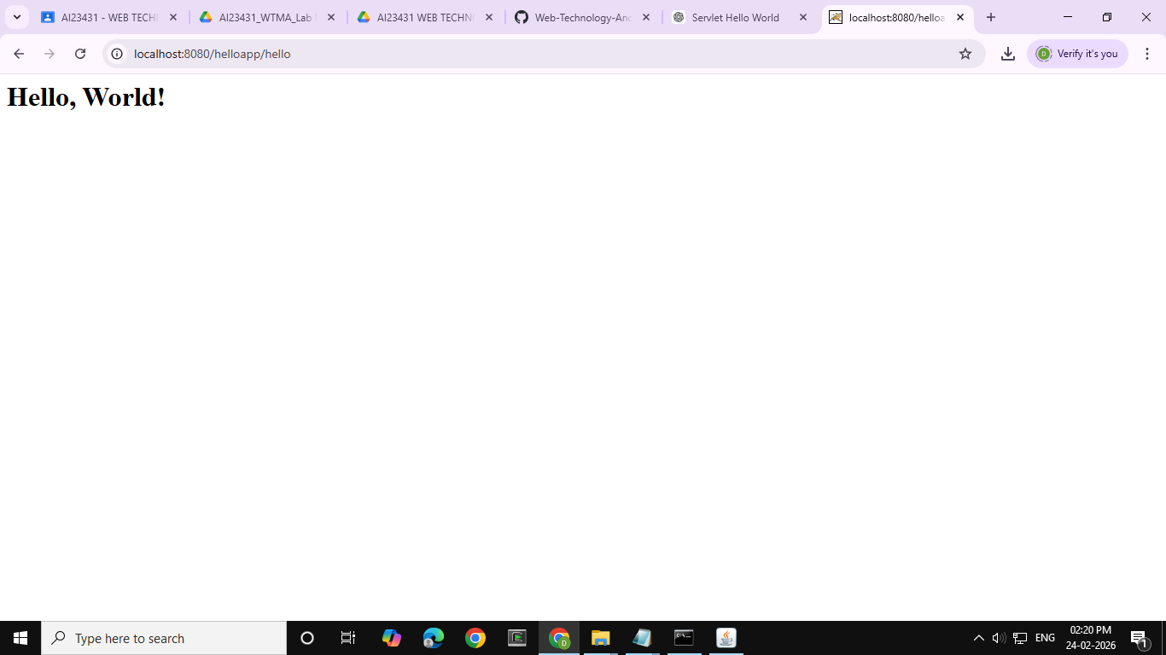

RESULT:
The browser will display the message “Hello, World!” returned by the Servlet..

